**2020江西专升本英语真题及答案**

本试卷分第Ⅰ卷(选择题)和第Ⅱ卷(非选择题)两部分，共150分。

**考生注意：**

1.答题前，考生务必将自己的准考证号、姓名填写在答题卡上。考生要认真核对答题卡上粘贴的条形码的“准考证号、姓名、考试科目”与考生本人准考证号、姓名是否一致。

2.第Ⅰ卷每小题选出答案后，用2B铅笔把答题卡上对应题目的答案标号涂黑，如需改动，用橡皮擦干净后，再选涂其他答案标号。第Ⅱ卷用黑色墨水签字笔在答题卡上书写作答。在试题卷上作答答案无效。

3.考试结束监考员将试题卷、答题卡一并收回。

**第Ⅰ卷选择题**

**Ⅰ.单项选择题（本大题共20小题，每小题1.5分，共30分）**

**从A、B、C、D中，选出可以填入空白处的最佳选项，并在答题卡上将该项涂黑。**

1. —Hi, Jane! How nice to meet you here in Shanghai!

—__________.

A That s all right     B. Me, too

C. Don t mention it   D. The same to you

2. He usually goes to work by_____bike, but sometimes on_____foot.

A. /;/  B. the;/ C. the; the D. /;the

3. _____you stay in China, _____you will learn about Chinese culture.

A. Longer; more   B. The longer; the more

C. Longer; the more     D. The longer; more

4. I_____a job as soon as I graduated from the university. but I turned it down.

A. am offered   B. offeredC. was offered D. offer

5. As a new teacher, I have some difficulty _____organizing discussions in class.

A. toB. atC. on      D.in

6. —Have you seen the new film?

—No, but I wish I _____.

A. had     B. did    C. have  D. do

7. He used to _____up late, but now he is used to _____up early.

A. get; get              B. getting; getting

C. get; getting                D. getting; get

8. A big fire broke out in his house last night _____, no one was hurt.

A. UnluckilyB. FortunatelyC. GraduallyD. Badly

9. —Did you feel happy when you first moved to New York?

—Not really. I was a little _____because I had no friends there.

A. perfect B. politeC. lonelyD. usual

10. When I returned home, I found I _____my umbrella in the office.

A. will leaveB. was leavingC. have left  D. had left

11. —What s in the box?

—I m not sure. It _____be a book.

A. mustn t B. mayC. needn t   D. can

12. — _____can you get to the airport?

— In one and a half hours.

A. How oftenB. How muchC. How longD. How soon

13. Not all the toys are second-hand; _____of them are new.

A. SomeB. allC. anyD. none

14. _____to the left, and you will find the path reaching to the top of the hill.

A. TurnB. Turning C. TurnedD. To turn

15. This is Mr Brown, _____I think has exciting news to tell you.

A. whichB.whoseC. whomD. who

16. —What does your aunt do?

—She is a _____and she has been working in the hospital for twenty years.

A. TeacherB. pilotC. nurseD. singer

17. The city has changed a lot It is加longer _____it was ten years ago.

A whenB. what C. whyD. that

18. My cousin hasn t decided _____to stay _____go home.

A. if; andB. whether; andC. whether; orD. if; or

19. Look! There are too many people on the bus. Let s _____the next one.

A. make upB. cut downC. hand inD.wait for

20. Not only _____her how to do it but he offered to help her as well.

A. did he showB. does he showC. he showsD. he sowed

**Ⅱ.完形填空（本大题共15小题，每小题2分，共30分）**

**阅读下面短文，从短文后所给各题的四个选项（A、B、C和D）中，选出可以填入空白处的最佳选项，并在答题卡上将该项涂黑。**

My husband, my four-month-old daughter and I set out on a five day driving journey from California to Washington. We had to  21  frequently because our little child needed to stretch from the car seat.

One of our stops was at a restaurant. Walking towards the front door, we  22  a gentleman standing at one side. He was clearly untidy, without shoes and wearing  23  cloths. We passed right by him and opened the  24  door. Then something told me to go back.

Holding my  25  in my arms, I turned around and said to the gentleman, “Sir. Are you  26  ?” He said, “Yes.” I then asked, “May we buy you  27  to eat?” He responded with, “Sure, I can order something myself.”

My husband opened the door and the gentleman went straight to the counter. I told him to order   28   he wanted. The manager of the restaurant came over quite quickly and looked frightened. I spoke  29  he had an opportunity to. “This gentleman will have lunch with us today,” I said. “Please add his order to our  30  .” The manager said with a frown(皱眉), “Okay.” We turned to our table and the gentleman said loudly and quickly, “Thank You!” We merely nodded andwere seated. Upon finishing our  31  , we were handed our bill. I asked my husband what the gentleman had  32  . One fresh orange juice, one coffee, one breakfast combination with some baked potatoes.

When we  33  the restaurant I looked for the gentleman  34   didn’t see him. This very small act just made my day. I hope the small  35  can also add some joy to his life, even if only for a few minutes.

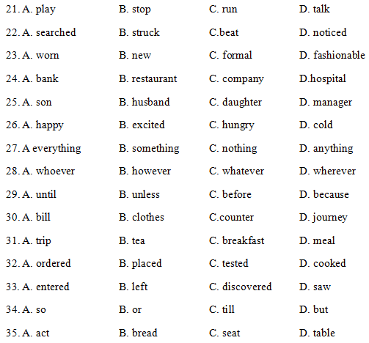

**Ⅲ. 阅读理解（本大题共25小题，每小题2分，共50分）**

**阅读下面短文，从短文后所给各题的四个选项（A、B、C和D）中，选出最佳选项，并在答题卡上将该项涂黑。**

**A**

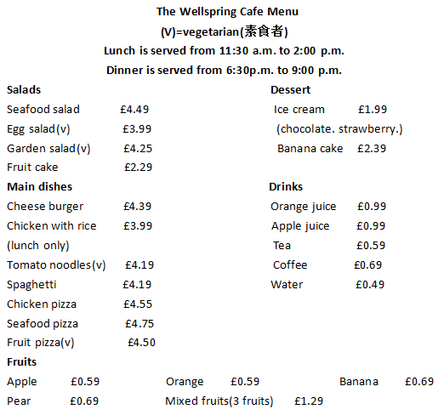

36. Dinner is served_____in the Wellspring cafe.

A.from 6:00 p.m.to 9:00 p.m.     B. from 11:30 a.m. to 2:00 p.m.

C.from 6:30 p.m. to 9: 00 p. m.    D. from 2:00 p.m to 9:00 p.m.

37. What is the most expensive food in the menu?

A. Cheese burger.            B Seafood salad.

C. Seafood pizza             D. Fruit pizza.

38. If you are a vegetarian, what can you order?

A. Egg salad and Chicken pizza.

B. Seafood salad and Chicken with rice.

C. Garden salad and Spaghetti.

D. Garden salad and Tomato noodles.

39. What is the price of Mixed fruits?

A. £2.99.    B. £1.99.9C. £1.29.     D. £0.69.

40. If you have £0.5, what drink can you buy?

A. Tea.      B. Water.C. Juice.   D. Coffee.

**B**

If someone asks me: Do you like music? I m sure I will answer him or her: Of course, I do.  I think music is an important part of our lives.

Different people have different ideas about music. For me, Ilike rock music because it s so exciting. And my favorite rock hand, the Eagles, is one of the most famous rock bands in the world. I also like pop music. My classmate Li Lan loves dance music, because she enjoys dancing. My best friend, Jane, likes jazz music. She thinks jazz is really cool.

I like dance music and rock very much, says my brother,because they are amazing.

But my mother thinks rock is boring.I like some relaxing music, she says, That s why she likes country music, I think.

41 The Eagles is the name of____.

A. a songB. a countyC. a schoolD. a band

42. What kind of music does the writer like?

A. Rock and pop music

B. Rock and dance music

C. Jazz and pop music

D. Jazz and country music

43. According to the text, who likes dancing?

A. The writer.B. Li Lan.

C. Jane.D. The writer’s mother.

44.The writer s mother thinks that county music is

A. amazingB. boringC. relaxingD.exciting

45. How many people s ideas about music are talked about in the text?

A. 4 B. 5 C. 6 D. 7

**C**

I have a neighbor. She looks young and beautiful although she is over 70.She can do all the housework, read newspapers and learn something new on the Internet I often see her do tai chi(大极拳) in the morning and dance in the evening.

Last week a reporter from a magazine asked her how she kept so young and healthy. She replied, I have a secret for staying young and healthy. It is quite simple. Keep your mind active, be interested in the world around and 1earn at least one new thing every day.” Don t think you are too old to learn. I know a man called Jack who started to study medicine in a college when he was 70 years old. He studied there for 6 years and now he works in a hospital. Another man called Barry began writing at the age of 71. And now he is good writer. Some people may think keeping 1eamning is easy only for young people. In fact, everyone can mike it.

It would be a good start to follow the old lady s example. I hope all the people will stay young and healthy.

46. The writer s neighbor, who,is over 70, looks_____.

A. old but healthyB. young but ugly

C. o1d and uglyD young and healthy

47. when did Jack begin doing study medicine in college?

A. At the age of 66.B. At the age of 70.

C. At the age of 76.D. At the age of 80.

48. What did Barry begin doing at the age of 71____?

A WritingB. DancingC SingingD Surfing

49.The text gives us some advice on______.

A how to be beautifulB. how to be a writer

C. how to stay young and healthyD. how to be a doctor

50.What’s the main idea of the text?

A. Live and learn.B. Like father like son.

C. Easy come easy go.D. No news is good news.

**D**

Have a great interest in the oceans? Now you can follow Blue Planet II and take a journey to the Earth s oceans. Blue Planet II is a British nature documentary series produced by the BBC Natural History Unit.

“I am truly excited to be joining this new exploration of the underwater world , which covers most of our planet. says 91-year-old Sir David Attenborough, the father of natural history TV, who returns as the teller, “The oceans are the most exciting place to be right now. because new scientific discoveries have given us new world of life underwater.

The BBC spent four years filming on every continent and in every ocean. I will take you to the deepest but least known parts of our planet. I s said that 95% of the world s oceans are unknown. You will be surprised at seeing a dolphin spitting water, a fish that uses,tools, and a hairy Hoff crab. The documentary will also take a close 1ook at underwater volcanoes(火山)。

However, you ll feel sad when you see these scenes: mother dolphins feeding their babies with dirt through their milk; man made noise drowning out the natural sounds, which animals use to communicate. Many creatures are trying hard for their lives.

Blue Planet II not only provides us with a great chance to enjoy sea animals, but also reminds us that this is the right moment for the health of the world s oceans.

51. Blue Planet II is a documentary series about______.

A. Sounds B. oceansC. ColorsD. tools

52. Who is Sir David Attenborough?

A. The reporter of the BBC.B. The manager of the BBC.

C. The teller of a news program.D. The father of natural history TV.

53. It is reported that we only know____of the worlds oceans.

A. 5%B. 91%C. 95%D.100%

54. What does the fourth paragraph imply?

A Animals can communicate with each other easily.

B. Natural sounds drown out man made noise.

C. Mother dolphins feed their babies with din<

D. Human beings are polluting oceans.

55. What does Blue Planet II remind us to do?

A. To protect oceansB. To enjoy a relaxing life.

C. To explore forests.D. To travel all over the world.

**E**

The idea of renting clothes might seem strange to some, but it s certainly not unheard of. Weddings, formal occasions, a fancy-dress party .. people rent clothes for these occasions all the time. But now some people are also renting clothes for everyday life, like friend gatherings, family trips or anytime they don t want to be the same, they choose to rent clothes instead of buying them.

As we know, the whole idea behind Fast Fashion is to wear clothes two or three times and then throw them away. This is where renting makes more sense. Many businesses have shown up over the last few years offering customers some kinds of dresses, which would only be voguish for one season. This way, one dress can be rented and worn by dozens of people, stopping each person from buying it themselves.

With a recent study showing that half of the young women polled said they felt the need to wear a different look every time they went out, renting clothes might just be the answer to the Fast Fashion problem. Not only can renting clothes be better for the environment, but consumers can also save money, and open up space in their home.

56. What is the Dew trend in renting clothes nowadays?

A. Renting, for weddings.B. Renting for daily life.

C. Renting for formal occasions.D. Renting for fancy, dress parties.

57. What does the underlined word drive mean in the second paragraph?

A. A journey.B. A vehicle. C. An effortD. A hit.

58. What is the problem of longer-lasting clothes?

A. Difficult to clean.

B. Hard to last for a long time.

C.Unfriendly to the environment.

D. Unpopular with some customers.

59. What can we learn from the text about renting clothes?

A. It s harmful.B. Its beneficial

C. It s unaffordableD. It s unavailable.

60. What is the writer s attitude towards the idea of renting clothes?

A. PositiveB. Critical

C. Indifferent.D. Negative.

**第Ⅱ卷 非选择题**

**Ⅳ短文改错（本大题共10小题，每小题1.5分，共15分）**

此题要求改正所给短文中的错误，对标有题号的每一行做出判断：如无错误，在该行右边横线画一个勾（√）；如有错误（每行只有一个错误），则按下列情况改正：

条一个词：把多余的词用斜线（）划掉，在该行右边横线上写出该词，并也用斜线划掉。

缺一个词：在缺词处加一个漏字符号（^）在该行右边横线上写出该加的词。

错一个词：在错的词下划一横线，在该行右边横线上写出改正后的词。

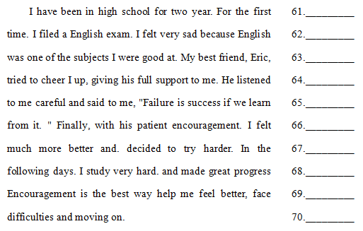

**Ⅴ书面表达（25分）**

71. 生命在于运动。保持身体健康，离不开运动。请你以Let’s run together为题。根据下面表格中的内容提示，写一篇介绍跑步这项运动的英语短文。

|  |  |
| --- | --- |
| 好处 | 1.提升耐力；  2.减轻压力；  3.变得自信；  4.结交朋友；  …… |
| 注意方式 | 1.穿舒适的衣服和鞋；  2.开始不要跑太快；  …… |

要点：

1.介绍跑步的好处；

2.提醒跑步的注意事项。

注意:

1.词数：100词左右，开头已经给出，不计入总词数；

2.可以适当增加细节，以使行文连贯。

参考词汇：耐力endurance；压力stress；自信的confident；舒适的comfortable；

**Let’s run together**

Nowadays, we are busy with our schoolwork. However, it s necessary to do sports, especially running.__________________________________________________________

___________________________________________________________________________________________________________________________________________________________________________________________________________________________________________________________________________.

**参考答案**

I单项选择

1-5：BABCD 6-10：ACBCD 11-15：BDAAD 16-20：CBCDA

II完形填空

21-25：BDABC 26-30：CBCCA 31-35：DABDA

阅读理解

36-40：CCDCB 41-45：DABCB

46-50：DBACA 51-55：BDADA

56-60：BCDBA

第II卷 非选择题

1.短文改错

61.year 改为years

62. a 改为an

63.were改为was

64.I改为me

65 .careful 改为carefully

66.对

67.去掉more

68. study 改为studied

69.way 后面加to

70.moving 改为move

**2001-2015、2020由省教育考试院统一命题，2001-2015真题见群文件，群号：1157274136。2016-2018采用PETS2上半年笔试成绩作为江西专升本英语成绩，2019由各高校独立命题。**

**—爱你们的柯南学长**